Spring-WebMVC Swagger 產生 REST API 文檔
REST API 文件
REST和微服務已經獲得了很大的發展動力。同時的 REST 規格並沒有建議任何標準方法來記錄我們將要公開的 REST API。結果，每個人都以自己的方式記錄他們的 API，導致所有人都可以輕鬆遵循、理解和使用的通用結構之間存在差距。我們需要有一個共同的模式和工具。
Swagger（由 Google、IBM、Microsoft 等公司支援）也做了相同的工作，填補了通用文件風格的空白。我們將學習使用Swagger 2 註解來產生 REST API 文件。

什麼是Swagger
Swagger（現在的「開放 API 計畫」）是一個規範和框架，用於使用每個人都能理解的通用語言來描述 REST API。考慮到其功能和開發人員社群的接受度，Swagger 目前最受歡迎。
它提供人類可讀和機器可讀的文檔格式。它提供 JSON 和 UI 支援。JSON可以作為機器可讀的格式，用於Swagger-UI視覺化顯示，人們只需瀏覽api文件就很容易理解。

專案結構和技術
項目的資料夾結構是：
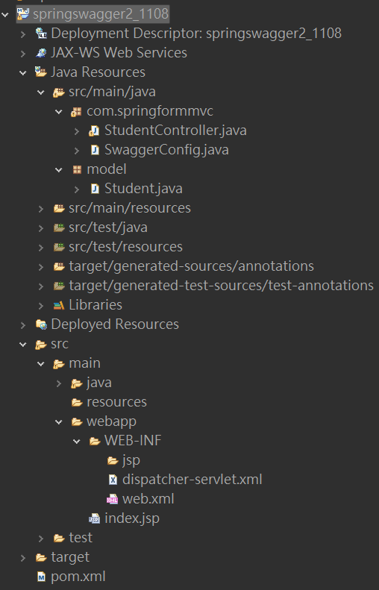
Swagger2 專案結構
建立 REST API
我們將首先建立一些 REST API，用於示範 Swagger 文件功能。我們將使用 Spring 風格來公開 REST API，以加快開發速度。
- 建一個maven web springswagger2專案
web.xml
<?xml version="1.0" encoding="UTF-8"?>
<web-app xmlns:xsi="http://www.w3.org/2001/XMLSchema-instance" xmlns="http://xmlns.jcp.org/xml/ns/javaee" xsi:schemaLocation="http://xmlns.jcp.org/xml/ns/javaee http://xmlns.jcp.org/xml/ns/javaee/web-app_4_0.xsd" id="WebApp_ID" version="4.0">
<display-name>springswagger2_1108</display-name>
<welcome-file-list>
<welcome-file>index.html</welcome-file>
<welcome-file>index.jsp</welcome-file>
<welcome-file>index.htm</welcome-file>
<welcome-file>default.html</welcome-file>
<welcome-file>default.jsp</welcome-file>
<welcome-file>default.htm</welcome-file>
</welcome-file-list>
<servlet>
<servlet-name>dispatcher</servlet-name>
<servlet-class>
org.springframework.web.servlet.DispatcherServlet
</servlet-class>
<load-on-startup>1</load-on-startup>
</servlet>
<servlet-mapping>
<servlet-name>dispatcher</servlet-name>
<url-pattern>/</url-pattern>
</servlet-mapping>
</web-app>

dispatcher-servlet.xml
<?xml version="1.0" encoding="UTF-8"?>
<beans xmlns="http://www.springframework.org/schema/beans"
xmlns:xsi="http://www.w3.org/2001/XMLSchema-instance"
xmlns:p="http://www.springframework.org/schema/p"
xmlns:context="http://www.springframework.org/schema/context"
xmlns:mvc="http://www.springframework.org/schema/mvc"
xsi:schemaLocation="http://www.springframework.org/schema/beans
http://www.springframework.org/schema/beans/spring-beans-4.1.xsd
http://www.springframework.org/schema/context
http://www.springframework.org/schema/context/spring-context-4.1.xsd
http://www.springframework.org/schema/mvc
http://www.springframework.org/schema/mvc/spring-mvc-4.1.xsd">

<context:component-scan base-package="com.springformmvc"/>
<context:annotation-config/>
<mvc:annotation-driven></mvc:annotation-driven>

<bean class="org.springframework.web.servlet.view.InternalResourceViewResolver">
<property name="prefix">
<value>/WEB-INF/jsp/</value>
</property>
<property name="suffix">
<value>.jsp</value>
</property>
</bean>
</beans>
- 新增一個 REST 控制器Swagger2DemoRestController，它將在Student實體上提供基於 REST 的基本功能。
- Swagger2DemoRestController.java
import java.util.ArrayList;
import java.util.List;
import java.util.stream.Collectors;
import org.springframework.web.bind.annotation.PathVariable;
import org.springframework.web.bind.annotation.RequestMapping;
import org.springframework.web.bind.annotation.RestController;
import com.example.springbootswagger2.model.Student;

@RestController
public class Swagger2DemoRestController {

List<Student> students = new ArrayList<Student>();
{
students.add(new Student("Telsla", "IV", "India"));
students.add(new Student("Amy", "V", "India"));
students.add(new Student("John", "III", "USA"));
students.add(new Student("Shelly", "VI", "USA"));
}

@RequestMapping(value = "/getStudents")
public List<Student> getStudents() {
return students;
}

@RequestMapping(value = "/getStudent/{name}")
public Student getStudent(@PathVariable(value = "name") String name) {
return students.stream().filter(x -> x.getName().equalsIgnoreCase(name))
.collect(Collectors.toList()).get(0);
}

@RequestMapping(value = "/getStudentByCountry/{country}")
public List<Student> getStudentByCountry(@PathVariable(value = "country") String country) {
System.out.println("Searching Student in country : " + country);
List<Student> studentsByCountry = students.stream()
.filter(x -> x.getCountry().equalsIgnoreCase(country))
.collect(Collectors.toList());
System.out.println(studentsByCountry);
return studentsByCountry;
}

@RequestMapping(value = "/getStudentByClass/{cls}")
public List<Student> getStudentByClass(@PathVariable(value = "cls") String cls) {
return students.stream().filter(x -> x.getCls().equalsIgnoreCase(cls)).collect(Collectors.toList());
}
}
SwaggerConfig.java

package com.springformmvc;

import org.springframework.context.annotation.Bean;
import org.springframework.context.annotation.Configuration;
import org.springframework.web.servlet.config.annotation.EnableWebMvc;
import org.springframework.web.servlet.config.annotation.ResourceHandlerRegistry;
import org.springframework.web.servlet.config.annotation.WebMvcConfigurer;
import springfox.documentation.builders.ApiInfoBuilder;
import springfox.documentation.builders.RequestHandlerSelectors;
import springfox.documentation.spi.DocumentationType;
import springfox.documentation.spring.web.plugins.Docket;
import springfox.documentation.swagger2.annotations.EnableSwagger2;

@Configuration
@EnableSwagger2
@EnableWebMvc
public class SwaggerConfig implements WebMvcConfigurer {

@Bean
public Docket api() {
return new Docket(DocumentationType.SWAGGER_2).select()
.apis(RequestHandlerSelectors.basePackage("com.springformmvc")).build()
.apiInfo(new ApiInfoBuilder().title("Person API").build());
}

@Override
public void addResourceHandlers(ResourceHandlerRegistry registry) {
// Enabling swagger-ui part for visual documentation
registry.addResourceHandler("swagger-ui.html").addResourceLocations("classpath:/META-INF/resources/");
registry.addResourceHandler("/webjars/**").addResourceLocations("classpath:/META-INF/resources/webjars/");
}

}

Student.java
public class Student {

private String name;
private String cls;
private String country;

public Student(String name, String cls, String country) {
super();
this.name = name;
this.cls = cls;
this.country = country;
}

public String getName() {
return name;
}

public String getCls() {
return cls;
}

public String getCountry() {
return country;
}

@Override
public String toString() {
return "Student [name=" + name + ", cls=" + cls + ", country=" + country + "]";
}
}

- 作為 Spring應用程式啟動應用程式。測試幾個 REST 端點以檢查它們是否正常運作：
  - http://localhost:8080/swagger2-demo/getStudents
  - http://localhost:8080/swagger2-demo/getStudent/Tesla
  - http://localhost:8080/swagger2-demo/getStudentByCountry/Amy
  - http://localhost:8080/swagger2-demo/getStudentByClass/v

Swagger2配置
我們的 REST API 已準備就緒。現在將 swagger 2 支援加入到專案中。ff
新增 Swagger2 Maven 依賴項
開啟專案的 pom.xml 檔案並新增以下兩個 swagger 相關依賴項 iespringfox-swagger2和springfox-swagger-ui。
<dependency>
<groupId>com.fasterxml.jackson.core</groupId>
<artifactId>jackson-annotations</artifactId>
<version>2.11.3</version>
</dependency>
<dependency>
<groupId>com.fasterxml.jackson.core</groupId>
<artifactId>jackson-databind</artifactId>
<version>2.11.3</version>
</dependency>
<dependency>
<groupId>com.fasterxml.jackson.core</groupId>
<artifactId>jackson-core</artifactId>
<version>2.11.3</version>
</dependency>
<!-- Swagger2 for API documentation -->
<dependency>
<groupId>io.springfox</groupId>
<artifactId>springfox-swagger2</artifactId>
<version>2.9.2</version>
</dependency>
<dependency>
<groupId>io.springfox</groupId>
<artifactId>springfox-swagger-ui</artifactId>
<version>2.9.2</version>
</dependency>

<dependency>
<groupId>org.apache.logging.log4j</groupId>
<artifactId>log4j-slf4j-impl</artifactId>
<version>2.14.1</version>
</dependency>

今天我們將使用，springfox因為這個版本可以很好地適應任何基於 spring 的配置。我們也可以輕鬆嘗試其他配置，並且應該提供相同的功能 - 配置沒有/幾乎沒有變化。

驗證 Swagger2 JSON 格式文檔
執行 maven 建置並啟動伺服器。開啟連結 http://localhost:8080/ springswagger2/v2/api-docs ，它應該以格式提供整個文件JSON。
這並不是那麼容易閱讀和理解，實際上 Swagger 已經提供了它可以在其他系統中使用，例如現在流行的 API 管理工具，它提供了 API 網關、API 快取、API 文件等功能。
JSON 文檔
驗證 Swagger2 UI 文檔
開啟 http://localhost:8080/springswagger2_1108 /swagger-ui.html 在瀏覽器中查看 Swagger UI 文件。
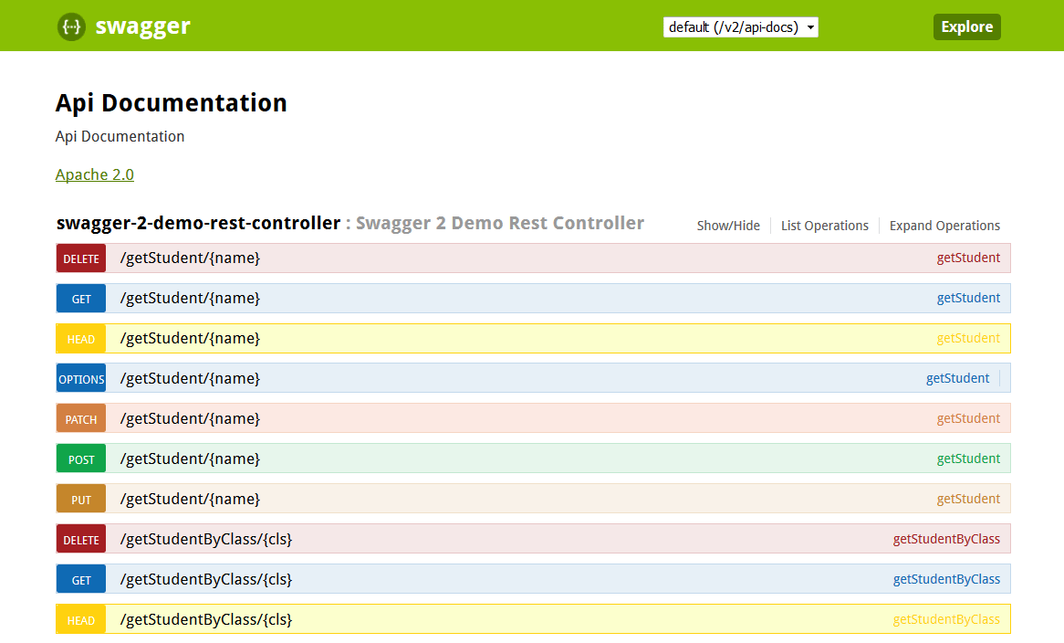沒有註釋的 Swagger2 UI 文檔

Swagger2 註釋
預設產生的 API 文件很好，但缺乏詳細的 API 等級資訊。Swagger 提供了一些註釋來將這些詳細資訊新增到 API 中。例如
- @Api– 我們可以將此Annotation添加到控制器中，以添加有關控制器的基本資訊。
@Api(value = "Swagger2RestController",
description = "REST APIs related to Student Entity!")
@RestController
public class Swagger2DemoRestController {
...
}
- @ApiOperation and @ApiResponses– 我們可以將這些註釋新增至控制器中的任何剩餘方法中，以新增與該方法相關的基本資訊。例如
@ApiOperation(value = "Get list of Students in the System ",
response = Iterable.class, tags = "getStudents")
@ApiResponses(value = {
@ApiResponse(code = 200, message = "Success|OK"),
@ApiResponse(code = 401, message = "not authorized!"),
@ApiResponse(code = 403, message = "forbidden!!!"),
@ApiResponse(code = 404, message = "not found!!!") })

@RequestMapping(value = "/getStudents")
public List<Student> getStudents() {
return students;
}
- 在這裡我們可以添加tags方法在swagger-ui.
- @ApiModelProperty– 此註解在 Model 屬性中使用，以為該模型屬性的 Swagger 輸出添加一些描述。例如
@ApiModelProperty(notes = "Name of the Student",name="name",
required=true,value="test name")
private String name;

新增swagger2註解後的Controller和Model類別程式碼。

Swagger2DemoRestController.java
package com.springformmvc;

import java.util.ArrayList;
import java.util.List;
import java.util.stream.Collectors;
import org.springframework.web.bind.annotation.PathVariable;
import org.springframework.web.bind.annotation.RequestMapping;
import org.springframework.web.bind.annotation.RestController;
import model.Student2;
import io.swagger.annotations.Api;
import io.swagger.annotations.ApiOperation;
import io.swagger.annotations.ApiResponse;
import io.swagger.annotations.ApiResponses;

@Api(value = "Swagger2DemoRestController", description = "REST Apis related to Student Entity!!!!")
@RestController
public class Swagger2DemoRestController {

List<Student2> students = new ArrayList<Student2>();
{
students.add(new Student2("Telsa", "IV", "India"));
students.add(new Student2("Amy", "V", "India"));
students.add(new Student2("John", "III", "USA"));
students.add(new Student2("Shelly", "VI", "USA"));
}

@ApiOperation(value = "Get list of Students in the System ",
response = Iterable.class, tags = "getStudents")
@ApiResponses(value = {
@ApiResponse(code = 200, message = "Suceess|OK"),
@ApiResponse(code = 401, message = "not authorized!"),
@ApiResponse(code = 403, message = "forbidden!!!"),
@ApiResponse(code = 404, message = "not found!!!") })

@RequestMapping(value = "/getStudents2")
public List<Student2> getStudents() {
return students;
}

@ApiOperation(value = "Get specific Student in the System ",
response = Student2.class, tags = "getStudent")
@RequestMapping(value = "/getStudent2/{name}")
public Student2 getStudent(@PathVariable(value = "name") String name) {
return students.stream().filter(x -> x.getName().equalsIgnoreCase(name))
.collect(Collectors.toList()).get(0);
}

@ApiOperation(value = "Get specific Student By Country in the System ",
response = Student2.class, tags = "getStudentByCountry")
@RequestMapping(value = "/getStudentByCountry2/{country}")
public List<Student2> getStudentByCountry(@PathVariable(value = "country") String country) {
System.out.println("Searching Student in country : " + country);
List<Student2> studentsByCountry = students.stream().filter(x -> x.getCountry()
.equalsIgnoreCase(country))
.collect(Collectors.toList());
System.out.println(studentsByCountry);
return studentsByCountry;
}

@ApiOperation(value = "Get specific Student By Class in the System ",
response = Student2.class,tags="getStudentByClass")
@RequestMapping(value = "/getStudentByClass2/{cls}")
public List<Student2> getStudentByClass(@PathVariable(value = "cls") String cls) {
return students.stream().filter(x -> x.getCls().equalsIgnoreCase(cls)).collect(Collectors.toList());
}
}

Student2.java
import io.swagger.annotations.ApiModelProperty;

public class Student2
{
@ApiModelProperty(notes = "Name of the Student",name="name",required=true,value="test name")
private String name;

@ApiModelProperty(notes = "Class of the Student",name="cls",required=true,value="test class")
private String cls;

@ApiModelProperty(notes = "Country of the Student",name="country",required=true,value="test country")
private String country;

public Student2(String name, String cls, String country) {
super();
this.name = name;
this.cls = cls;
this.country = country;
}

public String getName() {
return name;
}

public String getCls() {
return cls;
}

public String getCountry() {
return country;
}

@Override
public String toString() {
return "Student [name=" + name + ", cls=" + cls + ", country=" + country + "]";
}
}
示範
現在，當我們的 REST API 被正確註解後，讓我們看看最終的輸出。開啟 http://localhost:8080/ springswagger2/swagger-ui.html 在瀏覽器中查看 Swagger ui 文件。

